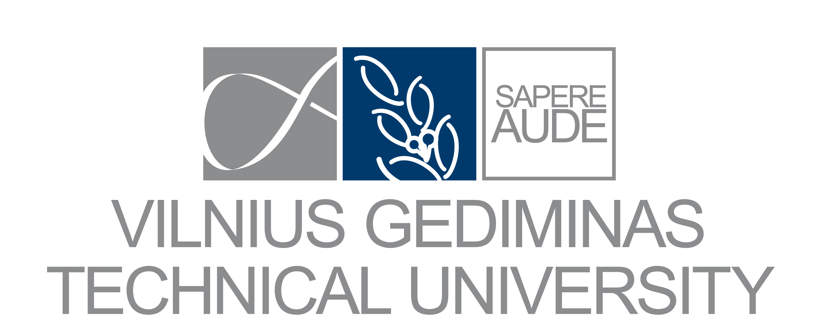

Confirmation of PERFORMED STAFF Mobility
under ERASMUS+ programme*

The undersigned hereby confirms that ANDRIUS JONAS KULIKAUSKAS, working at Vilnius Gediminas Technical University, Department of Philosophy and Cultural Studies, has completed training under Erasmus+ programme:

Name HOST enterprise/institution:  Ludwig-Maximilians-Universität München  Faculty / Department:  Department of Philosophy  Address:  LMU München  Geschwister-Scholl-Platz 1  80539 Munich  , Germany | Contact person (name, surname):  Prof Dr Peter Adamson  Contact details (phone, fax, e-mail):  peter.adamson@lrz.uni-muenchen.de
The training PERIOD from 2017-08-21 until 2017-08-23
Signed on behalf of the HOST enterprise/institution

Name and position:

Signature and stamp:

Date:
Place:

*This form should be completed, signed and stamped by the person responsible for the Staff training (STT) at host institution. Please write legibly.

